1. So, transpilers are the mythical third type of Harmony patch
2. [9:48 AM]

instead of running a method before or after the target method, you literally get the instruction list that the method is made of, and you can alter it. It's a bit harder, it requires you to understand IL code which is very similar to Assembly, but it's vastly more performant and powerful

**NEW**

1. [9:49 AM]

This is one I wrote a couple days ago, for example:

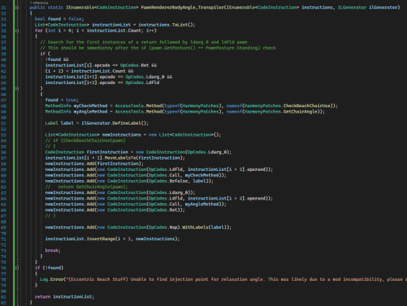

1. [9:50 AM]

It's essentially taking this method, and adding another if block inside it. (edited)

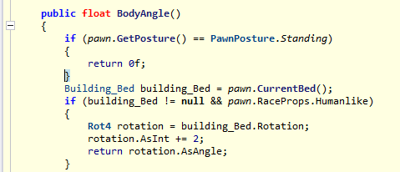

1. [9:52 AM]

So the final code (according to the game in memory) would be something like:

public float BodyAngle()

{

if (pawn.GetPosture() == PawnPosture.Standing)

{

return 0f;

}

if (CheckBeachChairUse(pawn)) {

return GetChairAngle(pawn);

}

Building_Bed building_Bed = pawn.CurrentBed();

// etc

}